Tab 1


Capstone Project Phase A
25-2-D-8

MuniMap
Interactive Map Interface for Municipal Incident Monitoring

Supervisor: Ph.D. Julia Sheidin
Alex Benderski alex517297a8@gmail.com

Table of Content:
Abstract ........................................................................................ 3
1. Introduction ............................................................................ 3
2. Background and Related Work ............................................ 4
2.1 Systems for Collecting Reports ......................................... 4
2.2 Systems for Displaying Reports ......................................... 8
2.3 The Role of Technological Solutions ..................................9
2.4 Barriers to Adoption and Design Considerations .............. 9
3. Expected Achievements ........................................................ 10
4. Development Process ............................................................ 11
4.1 Process ...............................................................................11
4.2 Product ...............................................................................12
4.2.1 System Architecture ....................................................12
4.2.2 Firebase Database Structure ....................................... 14
4.3 System Requirements ........................................................ 15
• Functional Requirements .................................................. 15
• Non-Functional Requirements ...........................................16
5. Diagrams ..................................................................................17
4.4 Use Case ............................................................................ 17
4.5 GUI Prototype ....................................................................... 18

5. Evaluation / Verification Plan ...............................................35
5.1 Testing Plan ........................................................................36
5.2 Evaluation by User .............................................................40
6. References .............................................................................. 41

Abstract
This project introduces a lightweight, web-based map system designed to support internal municipal workflows for handling citizen reports. While existing tools like “106” apps facilitate citizen reporting, internal municipal systems often lack spatial visualization, categorization, or filtering capabilities—resulting in limited operational insight and slower response times.

The proposed platform displays incoming reports on an interactive map, categorized by type and urgency, with filtering options for location, time, and category. Reports are visually differentiated using colors and icon styles to reflect their age and status, enabling staff to quickly identify recent or unresolved cases. Critical reports are also displayed in a dedicated alert panel to ensure visibility until addressed.

In addition, the system can automatically detect unusually high concentrations of reports in specific areas within defined time windows and flag them for further review. This allows city staff to proactively identify recurring issues or emerging problem zones.

Unlike complex GIS platforms such as ArcGIS, this system is optimized for daily use by non-technical staff, emphasizing clarity, usability, and responsiveness. It aims to improve municipal response efficiency and support better decision-making through a clean and accessible interface.

1. Introduction

Municipal governments manage a high volume of citizen reports concerning public services, infrastructure, and safety issues. These reports often arrive through fragmented, unstandardized channels—such as separate online forms, mobile apps, or spreadsheets—making it difficult for city staff to gain a clear spatial overview or prioritize issues effectively [1].

Although mobile platforms like Israel’s “106” allow citizens to submit reports easily, the internal tools used by municipal staff often lack geographic visualization, proper categorization, and meaningful filtering. Reports are typically presented as static lists, limiting situational awareness and making it harder to identify patterns or respond efficiently. While dashboards can enhance comprehension and decision-making—particularly when interactive and filterable—most existing systems are designed for passive monitoring rather than active operational use [2].

Geospatial dashboards—many of which are based on GIS platforms—gained wide popularity during the COVID-19 pandemic. However, evaluations revealed that most of these tools lacked features essential for daily municipal workflows. A review of 68 public dashboards found that the majority offered high-level statistics with limited interactivity, little local-level detail, and minimal contextual metadata, with only 63% of users finding them helpful for decision-making [3]. Similarly, while ArcGIS Dashboards provide powerful capabilities for geospatial visualization and trend monitoring, they are primarily designed for analyzing predefined data layers. In contrast, the system proposed in this project focuses on daily operational workflows. It offers a lightweight and adaptable alternative for municipal staff who need to manage dynamic, citizen-generated reports in the field—without requiring technical expertise or enterprise-level GIS infrastructure [4].

This project proposes a web-based map platform for internal municipal use, allowing staff to visualize, categorize, and filter reports by location, type, and urgency. Rather than relying on real-time data streaming, the system emphasizes clarity and accessibility. High-priority reports are highlighted and optionally shown in a dedicated alert panel, while routine reports remain on the map until resolved. Visual cues such as colors or marker styles indicate the report's age, helping users distinguish between recent and long-standing issues without the need for constant monitoring.

By leveraging modern web technologies and an intuitive interface, the system aims to streamline municipal workflows, reduce cognitive load, and support timely, evidence-based decision-making.

_______________________________________________________________

2. Background and Related Work
Municipalities worldwide are increasingly adopting digital platforms to handle citizen reports regarding infrastructure problems, safety hazards, and public service issues. These systems can generally be divided into two categories: systems that collect the data ( reports inserted by the users), and systems that display or manage these data. While many platforms are available, each one offers different levels of functionality, visualization, and accessibility for both citizens and city staff.

2.1 Systems for Collecting Reports
One of the most common systems in Israel is the 106 municipal hotline, which allows citizens to report local issues by calling a municipal service center or submitting a report through a basic app or website form, typically including a short description and an optional photo. In some municipalities, users can also attach their location manually and also to add photos.
While functional, this system lacks spatial and categorical visualization—such as an interactive map showing the location and type of each report—and provides no real-time feedback to city staff. Based on its simplicity and lack of integrated features, the system is considered low in technical complexity.
Reports are typically processed manually into municipal back-office systems and are viewed as basic lists, without an overview of their geographic distribution or urgency level [7].
Another example is the Urban App (mycity-app.co.il), a mobile user friendly platform that lets users report local issues by selecting a category, uploading a photo, and optionally sharing their location via GPS (see Figure 3). This improves the user experience, but the backend is still primarily list-based and limited in visualization tools for city officials [7].
The system carries a low-medium level of technical complexity due to its additional features compared to the traditional 106 hotline.
Internationally, the platform SeeClickFix is widely used, especially in the United States. It allows citizens to report problems through an app or website, supporting GPS-based location tagging and photo uploads. Reports are automatically routed to the relevant city department, improving the efficiency of handling issues. Importantly, the platform offers flexible implementation: while some cities use only the basic reporting and ticketing tools, others invest in advanced customization, integrating dashboards, visual analytics, and system-wide tracking tools. This adaptability makes SeeClickFix a versatile solution, though it may require varying levels of resources and technical integration depending on the city’s needs.

Summary – Pros and Cons of Collection Systems:
Feature | 106 Hotline | Urban App | SeeClickFix / CHI311
Accessibility | Very easy | User-friendly | High
photo support | In some municipalities yes | Yes | Yes
GPS | Yes | Yes | Yes
Visualization for staff | No | Limited | Depends on implementation
technical complexity | Low | Low-Medium | Medium to High
It is important to note that this system focuses on internal visualization and operational support, and is not intended to replace the official municipal notification channel.
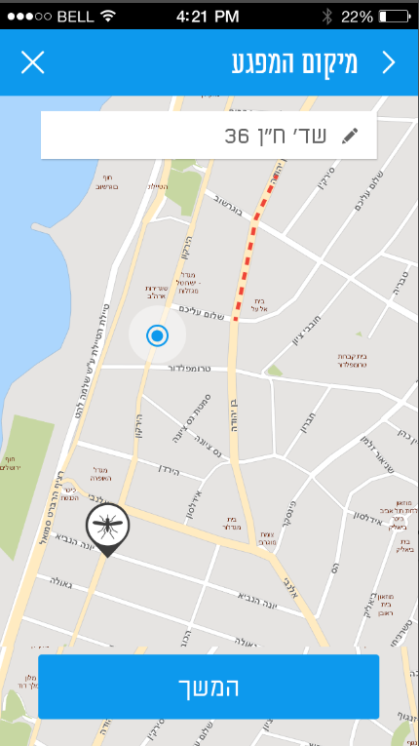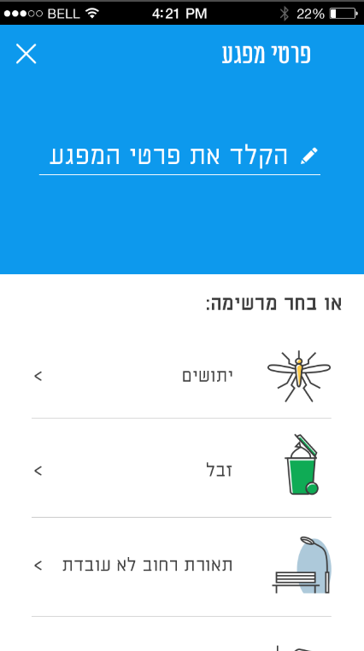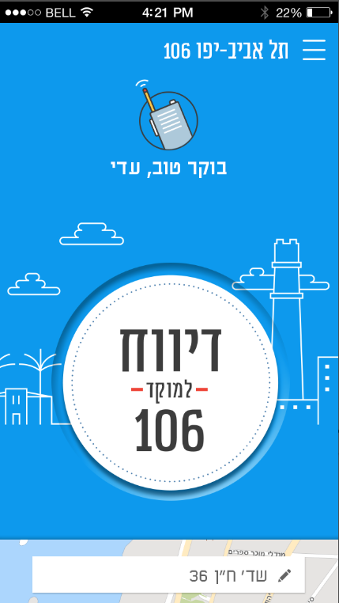
Figure 1: 106 app

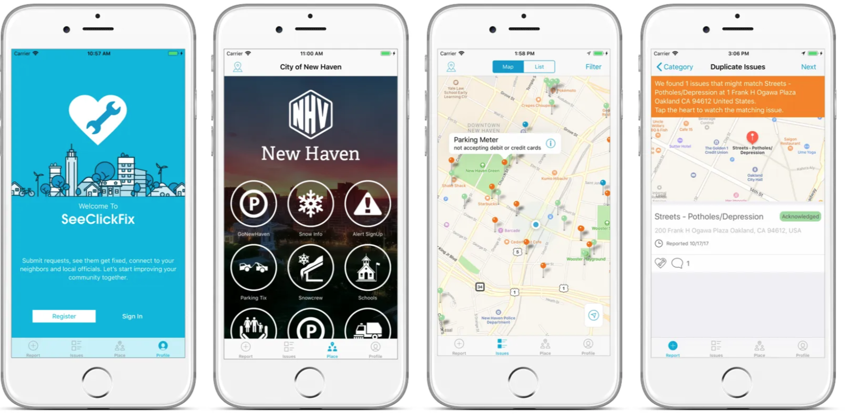
Figure 2: SeeClickFix app

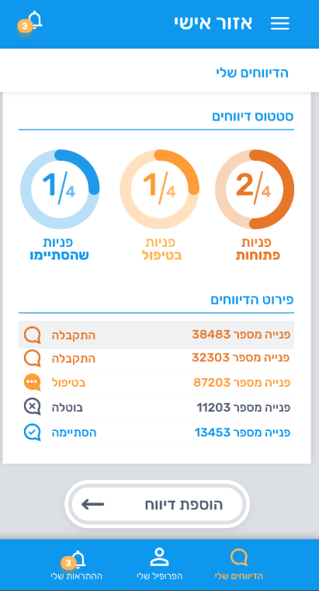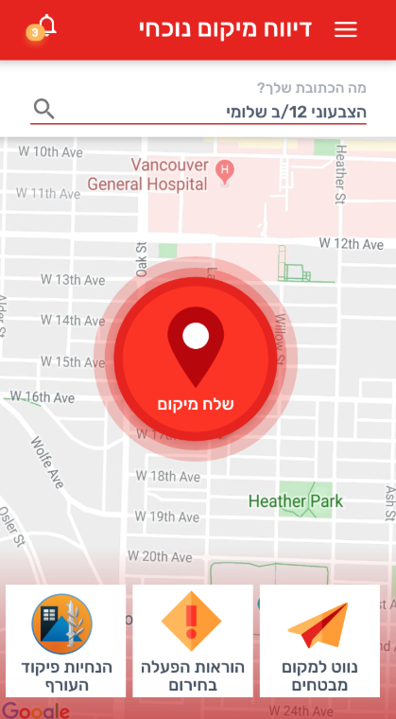
Figure 3: Urban app main screen

2.2 Systems for Displaying Reports
Some cities integrate GIS (Geographic Information Systems) with their CRM platforms to display citizen reports on a map. While powerful, systems like ArcGIS are often expensive, complex, and designed for trained professionals, making them less user-friendly, especially in advanced tools like ArcGIS Pro. Although they offer detailed map-based visualizations, the technical barrier is high, requiring expertise and resources that many municipalities lack.
CRM-based dashboards like Salesforce can support map-based visualizations, but often require additional modules, integrations, or licensing, making them less straightforward for municipalities seeking lightweight, dedicated reporting solutions.
Summary – Pros and Cons of Display Systems:

Feature | GIS Platforms | CRM-based Dashboards
User-friendly interface | No (especially in ArcGIS Pro) | Medium
Map-based report visualization | Yes (but often complex –ArcGIS) | Yes (but requires additional setup)
Technical barrier | Medium to High (Very high in ArcGIS Pro) | Medium

The system developed in this project aims to bridge this gap by combining lightweight, map-based visualization with a simple and intuitive interface that minimizes technical complexity. This approach ensures that municipal staff can access location-aware insights and prioritize tasks efficiently, without requiring specialized GIS training or heavy platform investments.

2.3 The Role of Technological Solutions
Technological advancements play a crucial role in enabling cities to respond efficiently to citizen needs. Intuitive interfaces and map-based visualizations help city staff make informed decisions faster. However, most existing solutions fall into two categories: either high-level business intelligence tools such as Tableau and Power BI, which are not inherently designed for map-based operational workflows, or complex GIS platforms like ArcGIS, which require specialized training and come with high costs [9].
The suggested system presented in this project offers a unique alternative: a lightweight, dynamic map-based platform built on Google Maps, tailored specifically for internal municipal use. It bridges the gap between basic citizen-facing reporting apps and high-end GIS systems by providing location-aware insights, simple filtering tools, and clear visual prioritization — all without requiring significant investment or technical expertise.

2.4 Barriers to Adoption and Design Considerations

Although map-based visualization offers clear advantages, it is not yet commonly adopted by municipalities. This may be due to several practical and organizational factors. Many municipal staff are used to working with table-based systems and lists, which offer direct access to report IDs, timestamps, and categories in a structured format. Switching to a spatial interface may require a change in workflow or mindset that not all staff are ready for [9].
Geographic Information Systems (GIS), such as ArcGIS, are technically powerful but often considered too complex for everyday use by administrative city staff. Several studies note that traditional GIS platforms require specialized knowledge and are primarily designed for analysts or engineers, making them less suitable for non-technical municipal employees. Furthermore, deleted reports are typically not preserved for historical analysis, and bulk operations such as closing or removing multiple reports are not supported without advanced configuration or scripting [9].
Even when considering sophisticated platforms such as ArcGIS — one of the most established and feature-rich GIS solutions available — certain limitations remain when applied to municipal reporting tasks. While ArcGIS offers powerful tools for spatial analysis and mapping, its configuration and day-to-day use often require advanced training, administrative permissions, and scripting for automation. Features such as historical access to deleted reports or bulk status updates are not readily available out-of-the-box and may demand custom development or licensing of additional components. These usability and operational barriers limit its effectiveness for frontline municipal staff who need a simple, responsive, and purpose-built reporting environment.[10]

3. Expected Achievements
The main goal of this project is to develop a lightweight and user-friendly map-based system, specifically designed for local governments to manage and present citizen reports more effectively. Unlike traditional GIS platforms like ArcGIS Pro, which are powerful but often too complex for daily use, this project focuses on accessibility and simplicity while maintaining essential spatial functionality.
The system will assist municipal employees in viewing, filtering, and managing reports using a dynamic map interface that reflects real-world locations and categories. While it does not replace public-facing reporting platforms like 106 or mobile apps, it serves as a visual and operational layer for internal staff to better track and respond to reported issues.
Additional capabilities are designed with the assumption that the system can be connected to the municipality’s internal database. This connection would enable automatic synchronization of report statuses without requiring manual file uploads. The system also retains resolved or deleted reports for historical reference and issues alerts when specific areas exhibit recurring issues. These features aim to provide municipalities with a focused and easy-to-use tool that aligns with actual operational needs.
The success criteria for this project will be:
- At least 80% of targeted municipal staff report that they can effectively understand and manage citizen reports using the map-based interface after minimal training (defined as no more than one hour).
- At least 80% of users indicate in the pilot questionnaire that the system is easy to use.
- At least 75% of users report that the system saves them time compared to the previous method.
- At least 70% reduction in reliance on complex GIS platforms (e.g., ArcGIS Pro) for daily operational tracking, as measured by feedback and usage statistics over a 3-month pilot.
- The system’s alert and visualization tools successfully detect at least 90% of recurring issues (defined as three or more similar reports in the same area within a one-month window) during internal tests.

4. Development Process

4.1 PROCESS
At the start of this project, I began by exploring and testing existing solutions to gain an initial understanding of available tools and approaches. I reviewed platforms such as the 106 municipal hotline and the Urban App, following discussions on social media and relevant forums to better understand how reports are collected and managed.
Next, I focused on analyzing software solutions specifically related to the core goal of this project — presenting collected citizen report data to municipal staff. Through this exploration, I identified the weaknesses of existing tools, particularly their complexity, non-intuitive interfaces, and overwhelming number of unnecessary features that reduce usability for daily municipal operations. This realization led me to conceptualize a purpose-driven system:
a lightweight web platform focused solely on delivering a clear, map-based visualization of municipal reports. By limiting the system to only the most relevant functions, it offers a simpler, more focused alternative to heavy and complex enterprise tools.
Regarding the type of data, I decided that because it is intended for the municipality, I will take all the issues existing in the citizen reporting applications, except for reports related to external parties such as water corporations. This data will be stored in the database in json format.
To strengthen the system’s design and theoretical foundation, I also conducted a literature review, drawing on relevant academic papers and studies to support the design decisions and validate the assumptions underpinning the project.
As for the database, I choose to use Firebase as the primary database, which stores data in JSON format. This choice allows for a flexible, real-time database structure that fits the dynamic nature of citizen report management.

Within the Firebase database, the list of reports is stored separately under a dedicated section (for example, titled “report locations”), making it easy to query, update, and manage the reports without interfering with other data types.

Each report entry under this section contains key information, including:
A text description (e.g., the type of issue reported)
A geographic location (coordinates for map placement)
Additional metadata (such as time of report, status, category, and optional image references)

After shaping a basic concept for the system, I moved on to consider the key features that could enhance its usefulness for municipal staff. To make it easier for staff to track reports and identify problematic areas, I proposed developing an automated process that scans report data and flags geographic zones with recurring issues.
Additionally, I considered how to visually distinguish between reports of the same category but from different submission times. A natural solution was to use color coding: for example, marking new reports in green, reports older than one week in gray, and reports older than one month in red.
Another important aspect was handling report deletion efficiently. Rather than linking the system to external tools or forcing manual deletion one by one, I decided to implement a file upload mechanism, allowing staff to submit a structured file (such as CSV) that automatically clears resolved reports in bulk.
As part of the design process, I carefully considered whether the system should display archived (old) reports directly on the map or only in tabular and statistical views. Since the system already includes an automated anomaly detection feature that highlights recurring issues in specific areas, I decided that showing old reports on the map would create unnecessary visual clutter without adding meaningful value. Instead, archived reports will be accessible through dedicated tables or summary reports, allowing municipal staff to review historical data as needed for managerial or documentation purposes, without overloading the primary map interface.

4.2 PRODUCT

4.2.1 System Architecture(see figure: “System architecture”):

1. React (Frontend)
The user interface is built with React, HTML/CSS, JavaScript, and Bootstrap. It serves as the primary interaction layer for municipal staff.
The React application communicates directly with Firebase through the Firebase Web SDK, enabling users to:
- View and filter incoming reports
- Interact with map views
- Change report statuses (open, pending, in progress, resolved)
- Explore anomaly alerts and analyze statistical summaries
This connection is bidirectional, as the interface both reads data and sends updates (e.g., status changes) back to Firebase.

2. Node.js (Back-End Server)
The backend is powered by a Node.js service that runs scheduled background tasks. These are not user-triggered, but instead activated periodically (e.g., every hour) via an internal scheduler or cron-like process.
This server uses the Firebase Admin SDK to securely access the Firebase services with elevated privileges.
The backend handles:
- Scheduled scanning of reports from the Realtime Database
- Anomaly Detection Logic (time-based or volume-based)
- Writing back newly detected anomalies or calculated statistics to the database
Although Firebase does not push data to the server, the communication remains logically bidirectional, as the server both reads and writes data.

3. Firebase (Data Layer & Management)
Firebase acts as the centralized data source shared across the system. It contains the following core components:
- Realtime Database – storing all reports, status history, anomaly logs, and statistics
- Authentication – enabling user login from the frontend interface
- Firebase Storage – used to hold uploaded images or media files attached to reports
- Firebase Admin SDK – used exclusively by the Node.js server to access Firebase programmatically with full permissions
Both the frontend (React) and the backend (Node.js) independently communicate with Firebase.
There is no direct connection between React and Node.js; all interaction occurs through the shared Firebase services.

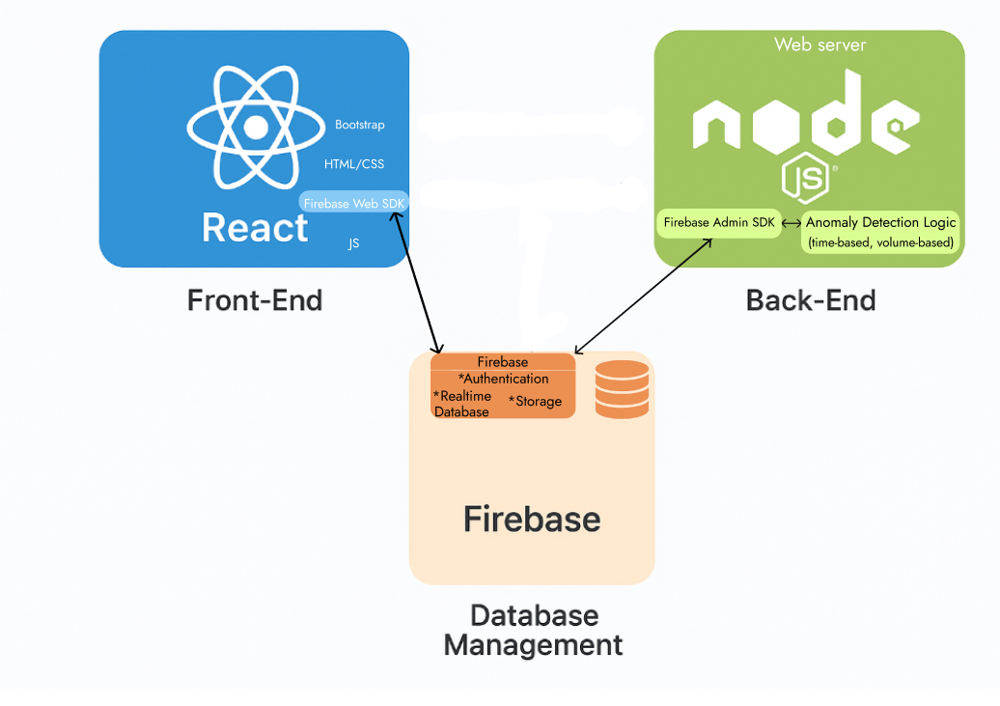
Figure: “System architecture”

4.2.2 Firebase Database Structure
To support the functionality of the MuniMap system, the Firebase Realtime Database is organized as a hierarchical, JSON-based tree that stores all relevant data in a scalable and accessible way.
The main data nodes include:
- reports – Contains all submitted reports. Each report is stored under a unique ID and includes fields such as timestamp, category, status, location, description, and optional media.
- anomalies – Stores system-generated anomaly entries created by the backend. Each anomaly includes metadata such as type, area, detectedAt, and the logic that triggered it (e.g., time-based or volume-based).
- archivedReports – Includes grouped or historical data exports, organized by month and year. These are typically accessed for download and are not editable.
- users – Optionally contains extended metadata (e.g., role or area of responsibility) for users authenticated via Firebase Authentication. Actual login credentials are managed securely via Firebase Authentication, not stored in the database.
- statistics – Stores preprocessed metrics calculated by the Node.js backend, such as:
  - Daily, weekly, monthly, and yearly summaries
  - Average resolution time
  - Top report categories
  - Unresolved report percentages
These statistics are used to improve performance when users select predefined time ranges like “This Week” or “This Month.”
For custom date ranges, the system dynamically calculates statistics from the full /reports node at runtime.
4.3 System requirements :
Functional requirements:
- The system allows the user to log in using a username and password.
- The system allows the user to open and view the full table of all reports.
- The system allows the user to view, change status, or delete individual reports.
- The system allows the user to view attached media (e.g., photos) associated with a report.
- The system allows the user to filter the full report table based on report category, status, date range, and area.
- The system includes an advanced filter panel for refining results based on multiple criteria.
- The system allows the user to search for a specific report or notification.
- The system allows the user to expand any report breakdown (by area or category) into a fullscreen table view.
- The system allows the user to display either a single report or all table reports on the map.
- The system enforces step-by-step status updates, allowing status to be changed only to the next valid stage.
- The system displays a visual timeline of status changes for each report in its detail view.
- The system allows the user to select multiple reports using checkboxes and delete them in a single action.
- The system allows the user to view grouped anomaly alerts and filter them by type, date, and area.
- The system allows the user to view detailed information about a specific anomaly, including its related reports.
- The system allows marking an anomaly as reviewed. Once marked, the alert becomes locked and cannot be re-edited.
- The system allows the user to select a date range for archived reports and displays a message if no data is available.
- The system allows the user to download archived reports in various formats, including by area, category, anomalies, and monthly summaries.
Non-Functional Requirements:
- Performance:
  - The system must load the full report table and map interface within 2 seconds under normal network conditions.
  - Graph rendering and anomaly table loading should complete within 2 seconds under normal conditions.
  - The system supports downloading archived reports by file type, including full records, grouped reports by area or category, and anomaly-specific exports.
- Scalability:
  - The system must support up to 10,000 active reports without noticeable performance degradation.
  - The system must support efficient handling of archived reports exceeding 50,000 records.
- Usability:
  - The system should require no more than 1 hour of training for a municipal employee to operate effectively.
  - The interface must be intuitive and minimize the number of clicks needed to perform key tasks.
- Reliability:
  - The system must maintain at least 99% uptime during municipal working hours.
  - System errors or crashes must not result in data loss.
- Maintainability:
  - The report categories are managed through the Firebase database and can be extended by the system administrator when needed.
  - Configuration files or database structures should be designed to support easy adjustments.
  - Exported file types should be easily configurable by administrators without modifying core code.
- Security:
  - User access must be protected by secure login (username and password).
  - Only authorized users can edit, delete, or upload reports and reports status.
  - Sensitive data, if any, must be stored and transmitted securely.
The system does not store original report data or handle status changes originating from the municipality's internal system; it functions in parallel as a viewing and monitoring tool.

4.4 Use case
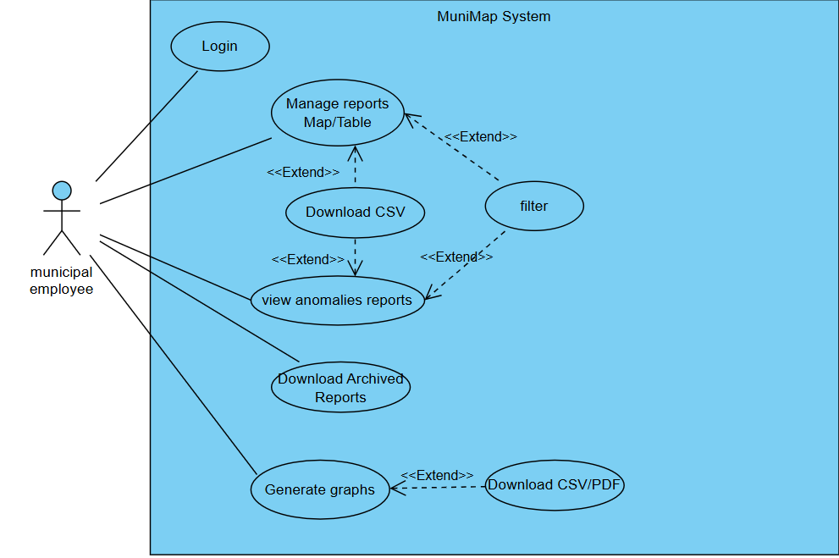

4.5 GUI Prototype
Main screens of MuniMap system:

Login screen:
The login screen(see figure:”Login screen”) is the first screen of the main MuniMap system.
If a user forgot the password he must contact the IT admin to reset his password/username.
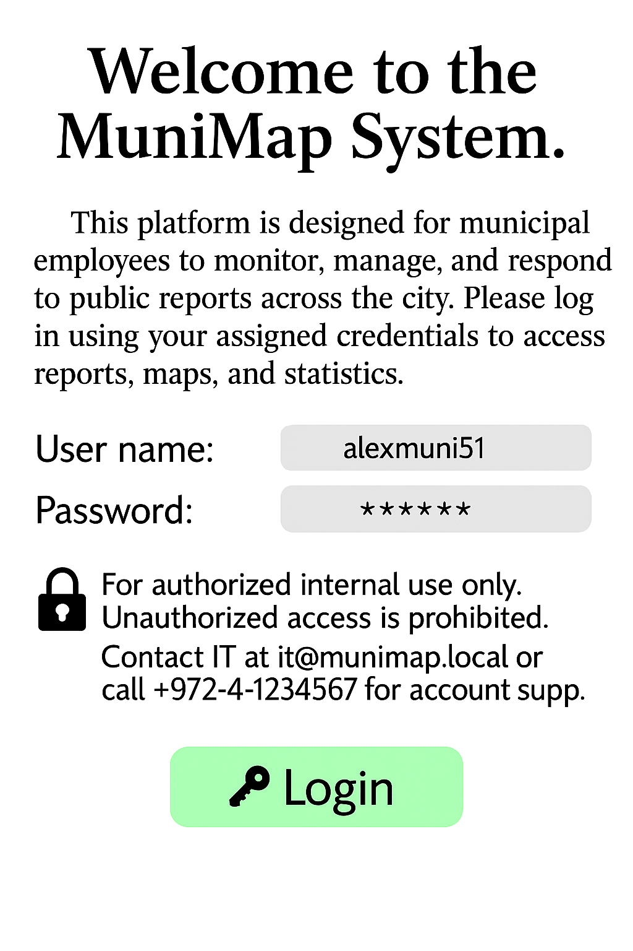
Figure:”Login screen”

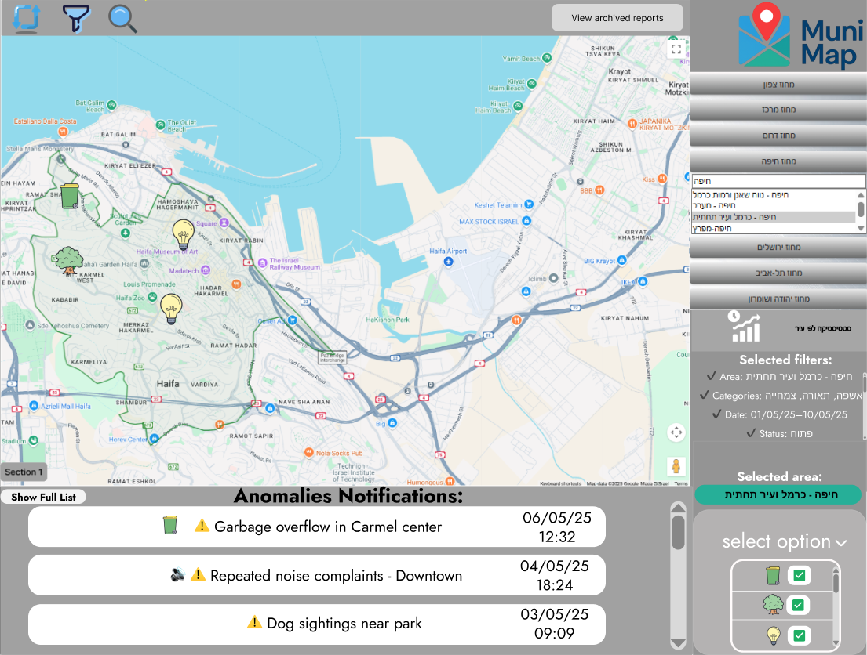
Figure:”Main screen” of MuniMap system
Upper toolbar:
- Pressing the refresh button will refresh the map and set filters to default.
- pressing the filter button will open the “Sort reports” screen, where the user can filter the reports that are shown on the map.
- Pressing the search button will open the “Reports Table” screen where users can search for a specific report or group of reports.
- Pressing the View archived reports button will open the screen(see figure:”Archived reports download page”) where users can download various archived reports.

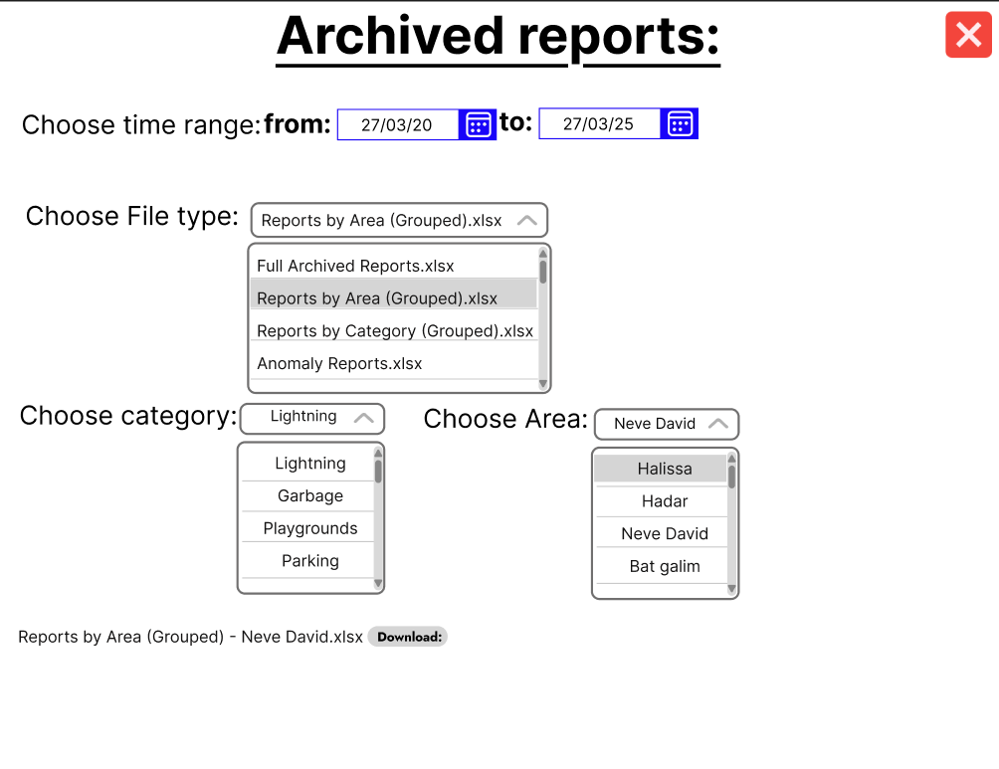
Figure: “Archived reports download page”

Archived reports download page screen:
This screen allows users to export archived reports based on a selected time range and file type. Users can choose from multiple report formats, including full archives, grouped reports by area or category, and anomaly summaries.
Additional filters such as category and area are available when relevant.
Once selected, a downloadable Excel file is generated for offline use and analysis.

________________________________________________________________
Right toolbar:
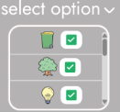
Figure: “select option”

- By pressing on the select option(see figure “select option”) , the users can select the wanted report types to show on the map(This option selects all the reports without filters).
- By pressing on one of the sections under the MuniMap logo, users can select the desired area they want to observe.(see figure: “Areas select section:”)
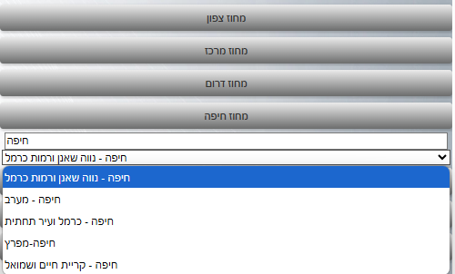
Figure: “Areas select section”

When desired area was selected, it will update in the “selected area” in the “main screen”

Figure: “Selected area”

-By pressing the “statistics button” right below the selection areas section,
It will open the “Statistics reports and Analysis” screen.

Figure: “Statistics button”

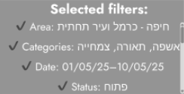
In the “Main screen”, when the filter is applied we will see the filters details.

________________________________________________________________

Down toolbar:(see figure “Anomalies Notifications”)
Users can watch in that notifications window then latest anomalies.
- By pressing on “show full list” users can open a full anomalies list.
- By pressing on one of the “Anomalies Notifications” the users can open the specific anomaly window with all the information about it.
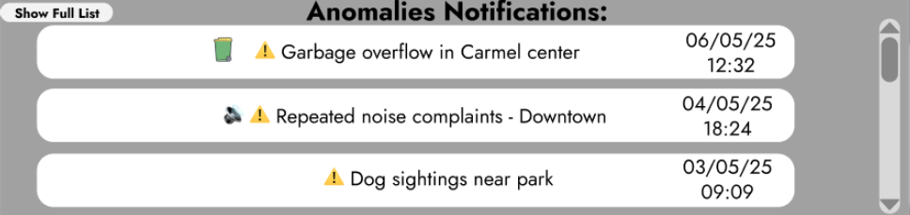
Figure: “Anomalies Notifications”.
________________________________________________________________

This screen(see figure:” Anomalies list”) appears after clicking on “show full list” from the down toolbar in the “main screen”. Users can view the various anomalies and also click on the “Open Reports” to see a table with all the anomaly details(see figure :”Anomalies Reports table “).
By clicking on the “filter and sort” button, a window with sorting options will open(see figure: “filter anomalies”).
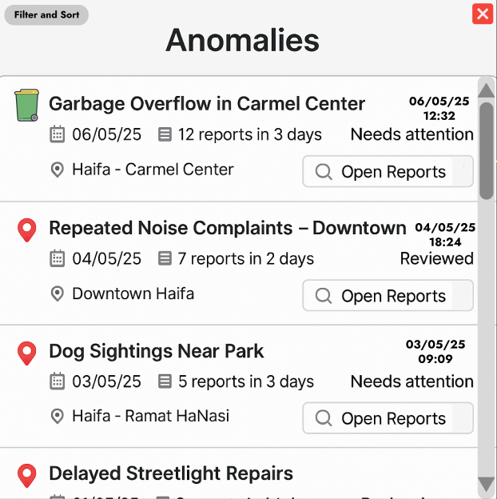
Figure: “Anomalies list”.

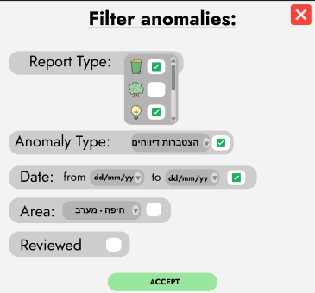
Figure: “Filter anomalies”.

Filter anomalies screen:
The screen(see figure:”Filter anomalies”) will appear after the user clicks on the “filter and sort” button in the “Anomalies list”.
The user can select various filters such as report type, anomaly type, date and area of the anomaly.
By clicking on accept the filter will apply to the “Anomalies list”.
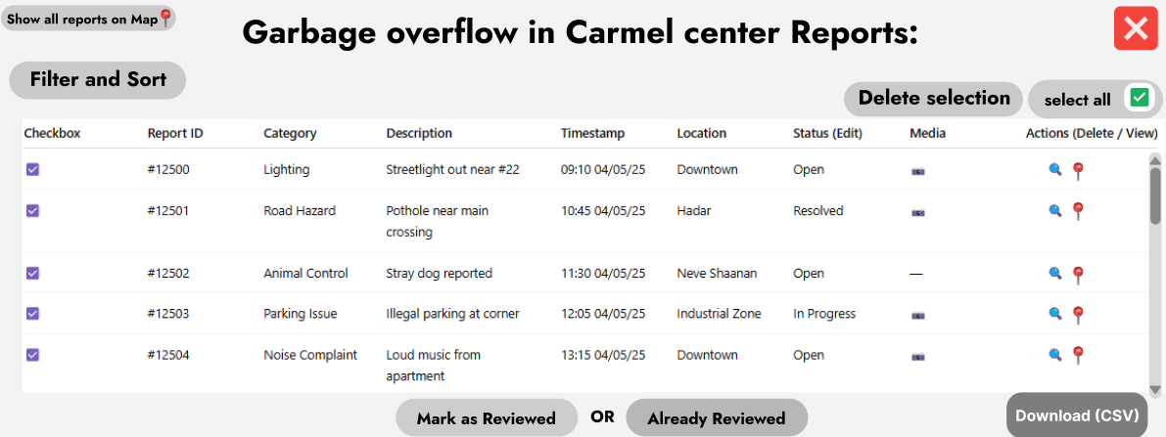
Figure: “Anomalies Reports table”.

Anomalies Reports table screen:
The screen (see figure:“Anomalies Reports table”) will be seen after the user clicks on the”Open reports” button from the “Anomalies list” screen.
Users can filter reports by clicking the “Filter and Sort” button, select multiple actions and delete them by clicking “Delete selection” button, download table CSV, view specific reports, show selected reports or a specific report on map and open the media if it is available.
If the anomaly is already reviewed, the user will see the “Already Reviewed" button that will be locked. Otherwise, the user will see a “Mark as Reviewed” unlocked button that the user can click to mark this anomaly as a reviewed one.
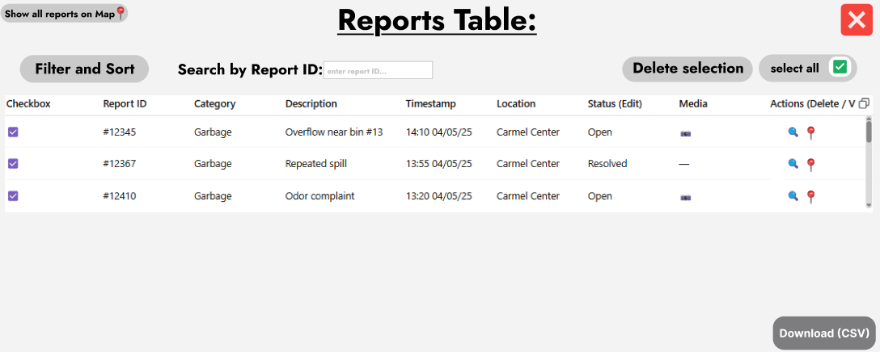
Figure: “Reports Table”.

Reports Table Screen(see figure:“Reports Table”):
The screen “Reports Table” will be seen after clicking the search button from the main screen. This is the default reports table that has been selected with filters from the main screen map. The table has similar options like the Anomalies Reports table, but also there is an option to search by report id.
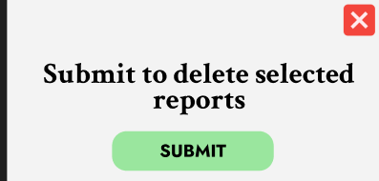
Figure: “delete selected reports popup window”.

After selecting in any table multiple lines and clicking on the “Delete selection” button, a popup window will appear and ask to submit (see figure: “delete selected reports popup window”).

selected reports on the map screen:
After clicking the “Show all reports on map” button from any table, it will open a new screen with a map and show all the selected reports from the table on the map(see figure:”selected reports on the map”).
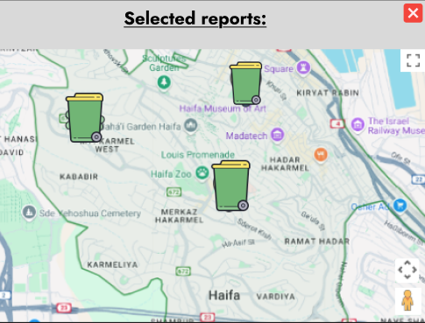
Figure: “selected reports on the map”.

Specific report on map screen:
After clicking on the “show on map”📍 action from any table, it will open new screen(see figure: “specific report on map”) with report id at the top of the page and the report icon on the map.

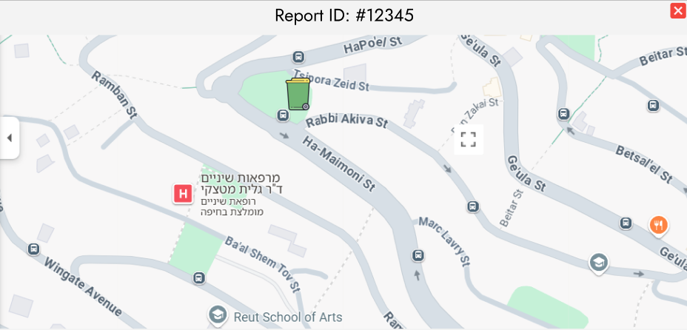 Figure: “specific report on map”.

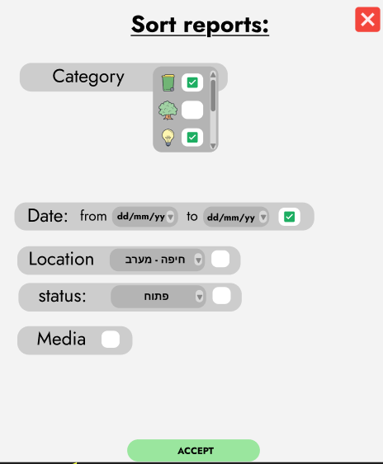
Figure: “Sort reports”.

Sort reports screen(see figure: “Sort reports”):
will appear after the user clicks on the “filter and sort” button in the “All reports” screen.
The user can select various filters such as report type, anomaly type, date,location,status and if the report includes media or not.
By clicking on accept the filter will apply to the “Filter reports window”.

Photo reports window:
The screen(see figure:”Photo reports”) will appear after clicking on the media icon from any table that has one. Users can view the photos related to the report.
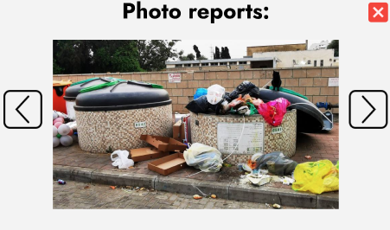
Figure: “Photo reports”.

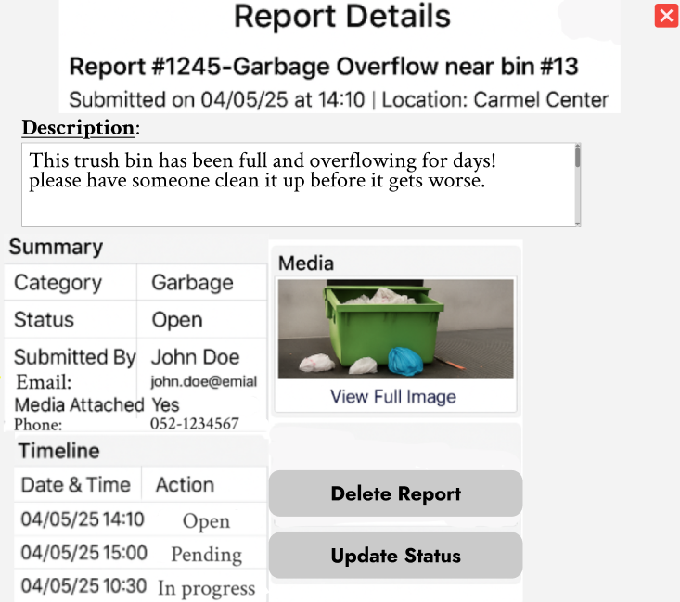
Figure: “Report details”.

Report Details view screen:
The screen(see figure:”Report details”) will appear after clicking on the
On the view🔍 action from any table that has one.
This screen will show all the details about the report like:description, category, status, by who submitted and so on. Also, there is a timeline that shows the steps that the report goes through.
Clicking on the “Delete Report” button will open a popup window(see figure: “Submit to delete popup”).
Clicking on the “Update Status” button will open a popup window(see figure: “Update status popup”). the user will be able to update only to the next status, the correct order is: open → pending → in progress → resolved .

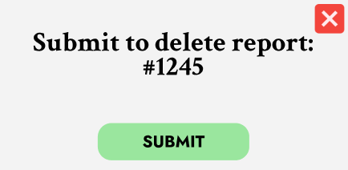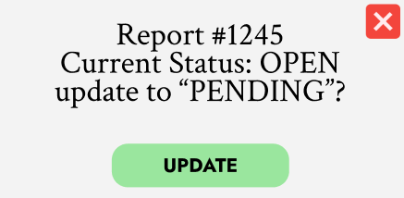
Figure: “Submit to delete popup”. Figure: “Update status popup”.

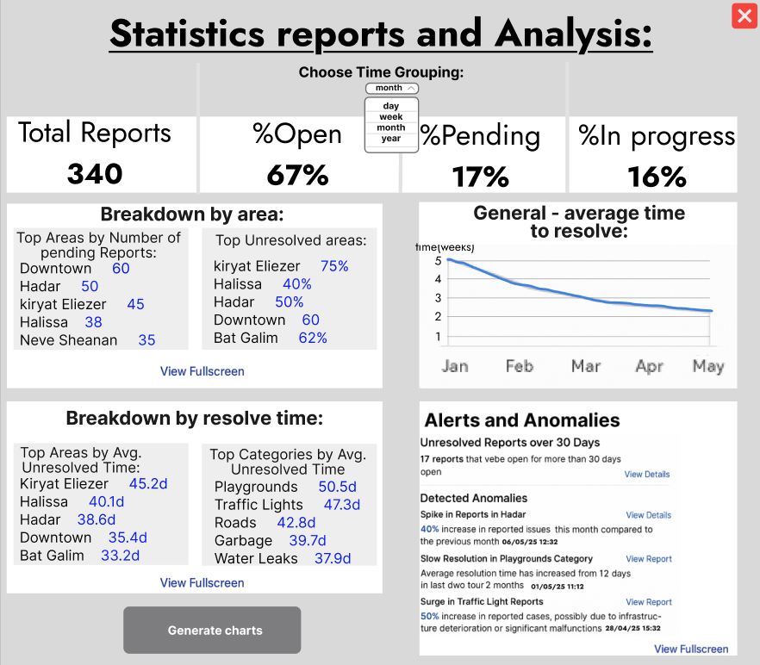
Figure: “Statistics reports and Analysis”

Statistics reports and Analysis screen:
This screen presents a general overview of municipal report activity, including status distribution, performance trends, and unresolved issue highlights.
The data can be grouped by time (day, week, month, year), and key insights are provided through breakdown tables, charts, and anomaly alerts.
Users can view detailed data in fullscreen by clicking the “view fullscreen” button or proceed to generate advanced charts by clicking the “Generate charts” button. By clicking the “view fullscreen” from the “Alerts and Anomalies” section, it will open the same section in a new big window.
By clicking the “View Report” option from the “Alerts and Anomalies” section. It will open a detailed report of a specific anomaly and also show a reports table(see figure: “Detailed anomaly report”).

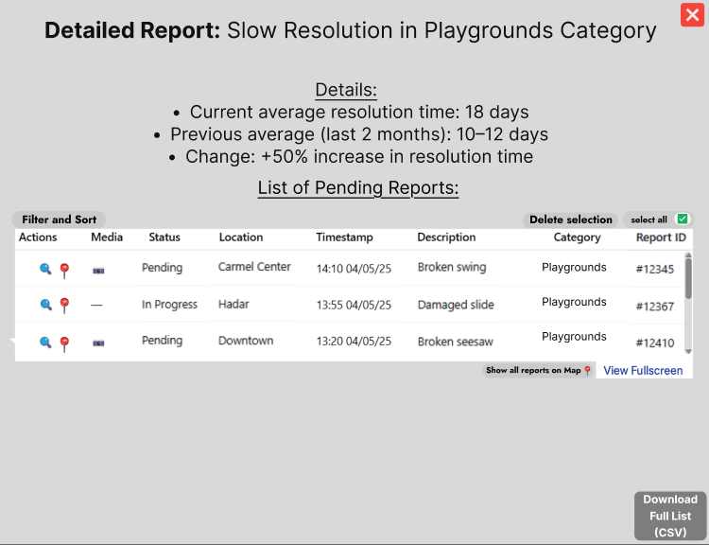
Figure: “Detailed anomaly report”

Detailed anomaly report screen:
This screen appears after selecting “View Report” from the Alerts and Anomalies section. It presents a focused anomaly case—in this example, slow resolution in the Playgrounds category. The screen shows current vs. previous resolution time and the percentage change.
A detailed table lists relevant pending or in-progress reports, including full metadata and management options.
Users can access the full list, view locations on the map, or export the data to CSV.

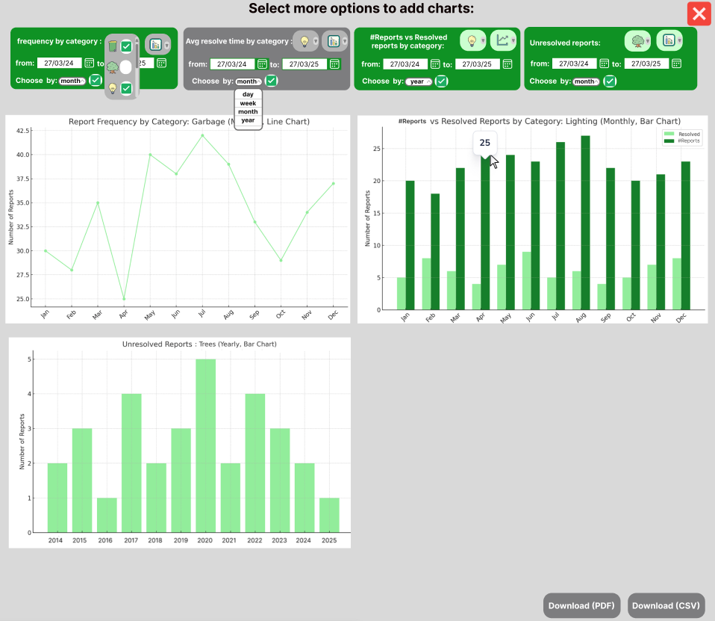
Figure: “Chart Generation Screen”

Chart Generation Screen:
The screen(see figure:“Chart Generation Screen”) will appear after clicking the “Generate charts” button from the “Statistics reports and Analysis” screen.
This screen can present multiple dynamic charts based on municipal report data.
Each chart includes its own date range selector and grouping option (day, week, month, or year), allowing flexible comparisons.
Displayed charts include:Report frequency by category,Total reports vs. resolved reports by category and Unresolved reports.
The user can customize each chart independently and download the results as PDF or CSV for further analysis.
If the user selected time range the ‘choose by’ option won't be available

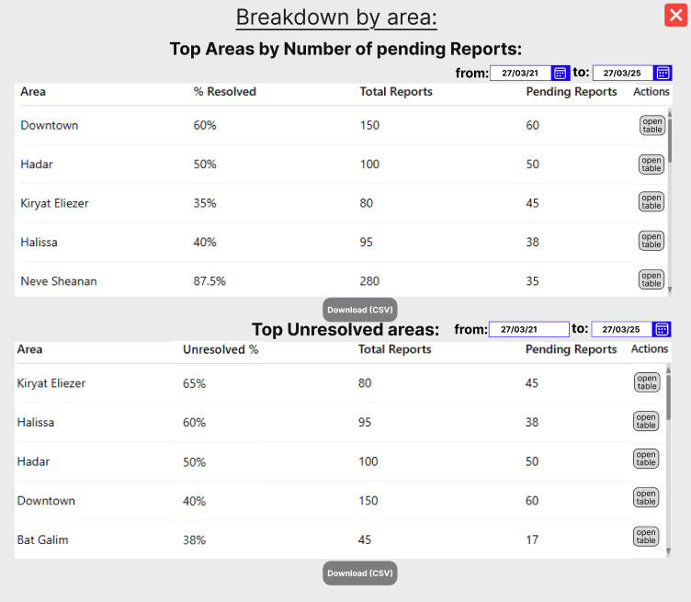
Figure: “Breakdown area Screen”

Breakdown area Screen:
The screen(see figure: “Breakdown area Screen” ) will appear after clicking the “view fullscreen” button in the breakdown by area section or from the breakdown by resolve time, all that from the “Chart Generation Screen”.
Each table includes resolution rate, total reports, and pending counts, with individual date range filters.
Users can access detailed tables per area or export the data as CSV for further use.

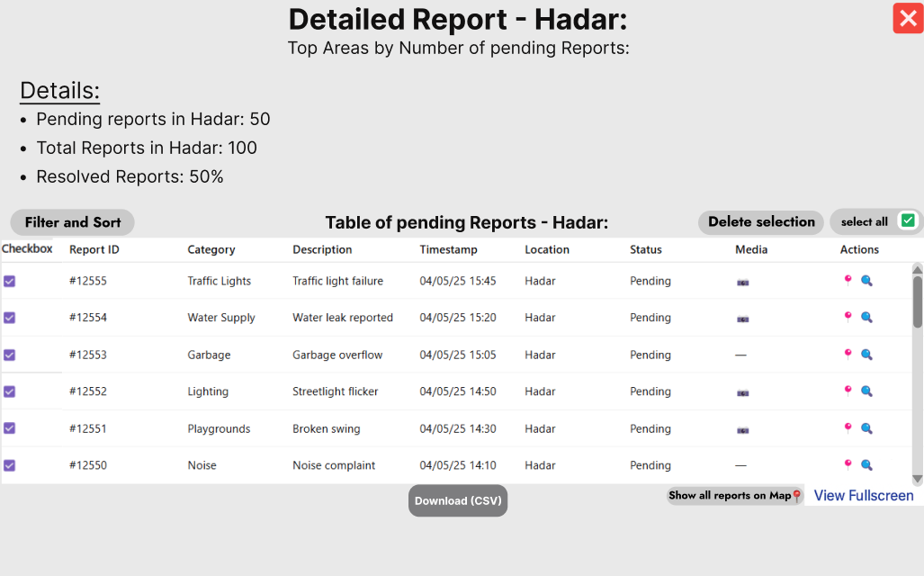
Figure: “Detailed Report – Area View Summary”

Detailed Report – Area View Summary:
This screen appears after clicking "Open Table" from the breakdown section. It provides a focused view of a specific area — in this case, Hadar — showing details such as total reports, pending count, and resolution rate.
A detailed table lists all pending reports from that area, including category, description, timestamp, and media.
Users can filter, sort, select multiple reports, delete, or view them on the map.
Export is available via Download CSV, and users can open the full report list in fullscreen(see figure:”Detailed Report table full screen “ ).

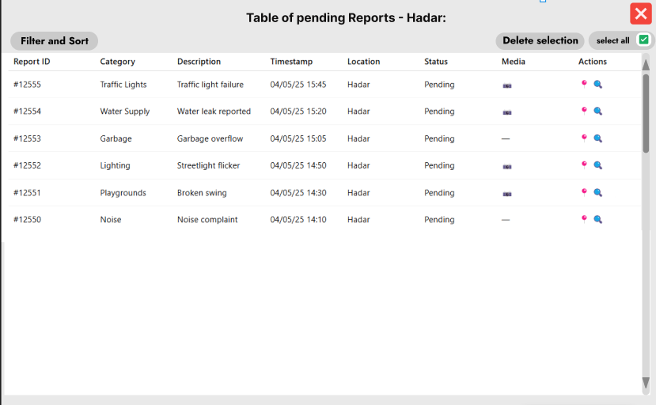
Figure: “Detailed Report table full screen”
Detailed Report table full screen:
This screen displays a full, scrollable table of all pending reports for a selected area. It is accessed via the “View Fullscreen” option from the “detailed area report screen”. Users can filter, sort, select, and perform actions on individual or multiple reports. This view is designed to support efficient review and management of report data.
________________________________________________________________
5. Evaluation / Verification Plan
To ensure the system operates correctly and as intended, I will evaluate it through the following
steps:
1. Execute the testing plan.
2. Have the system used by two representative users: Administrative Data Analyst and a Technical Report Handler.

5.1Testing Plan

To ensure the reliability, accuracy, and usability of the MuniMap system, a structured testing plan was developed.
This plan is based on the system's use case diagrams, GUI screens, and expected real-world workflows.
Each test case focuses on a core functionality or user interaction, allowing us to identify potential issues, unexpected behaviors, or areas that require improvement.
The testing includes both success scenarios and edge cases, including incorrect inputs, empty states, and logical constraints.
# | Test Subject | Test Scenario | Expected Result
1 | User Authentication | Login with wrong credentials | An error message is shown and login is denied.
2 | User Authentication | Login with empty fields | The system prevents submission and highlights required fields.
3 | Report Filtering | Apply invalid date range (start date > end date) | The system shows validation errors and blocks the filter.
4 | Archived Reports | Select date, file type and optional category and click 'download' | The selected XLSX file is downloaded successfully.
5 | Archived Reports | Click on 'archived reports' button from map screen | The archived reports screen loads successfully.
6 | Report Status Update/Delete | Click 'update status' or 'delete report' and confirm | Status is updated or report is deleted in DB and timeline.
7 | Map Filters | Apply filters via the filter button on main map | Map is updated correctly based on selected filters.
8 | Search by Report ID | Enter valid report ID and search | Table updates and shows the report.
9 | Search by Report ID | Enter invalid report ID and search | Validation error shown, table remains unchanged.
10 | Delete Reports | Select multiple reports and click 'delete selection' | Selected reports are removed from the table.
11 | Delete Reports | Click 'delete selection' with no reports selected | The system shows 'no reports were selected!' error.
12 | Table Refresh | Click on the 'refresh' button in main screen | All filters are cleared and table resets.
13 | Region Selection | Select a region from right sidebar | Map filters update, selected region appears in summary. The map remains empty.
14 | Region and Category Selection | Select region and category together | Map updates, both filters are shown and icons updated on the map
15 | Manual Report View on Map | Click report icon on map | A detailed report screen opens with full information.
16 | Anomalies | Click on anomaly in main screen | Anomaly reports table is shown.
 |  | Click on ‘show full list’ on the main screen. | Anomalies list loaded successfully.
 |  | Filter was selected on anomalies list | Anomalies list was updated by selected filters.
 |  | Open unreviewed anomaly report table. | ‘Mark as reviewed’ option is available.
 |  | Open reviewed anomaly report table. | ‘Already reviewed’ text is shown right below the table.
17 | Statistics and Analysis | Click on the ‘statistics’ icon on the main screen. | All report data and analysis information loaded without problems.
 |  | Select ‘time grouping’ to year. | The data updated to 1 year data.
 |  | Select invalid time(above 1 year range). | An error message is shown and mentions a valid range.
 |  | Select valid time range. | Desired breakdown table shown.
 |  | Click the open table from the breakdown table. | Detailed report shown with
18 | File download | Click the Download CSV/PDF button. | A detailed report screen opens with information and a table.
19 | Full screen table | Click the ‘view fullscreen’ button. | The new screen opens with the desired table.
20 | Show reports table→map | Click ‘show all reports on map’ | All the reports from the table shown on the map in the new window.
 |  | Click on ‘show all map’ action in the table. | The desired report from the table shown on the map in the new window.
21 | Statistics Charts | Hover over a chart point. | Tooltip appears showing correct parameters.
 |  | Time wasn't selected and a click was made on the chart button. | An error message is shown.
 |  | Invalid time was selected. | An error message is shown.
 |  | All the options were selected and a click was made on the relevant button. | The chart displays data correctly.
 |  | Switch quickly between different chart types and categories | No crash or lag, charts refresh correctly
 |  | Click "Download PDF" with at least one chart on screen | PDF with visible charts is downloaded successfully

5.2 Evaluation by User

Technical Report Handler Evaluation:
I will ask the technical staff member to simulate a real working scenario:
The user will begin by viewing the interactive city map, apply filters by area and report category, and identify a report of interest.
Then he will switch to the detailed report table to locate the same report and compare both representations.
After reviewing the report’s content, the user will try to change its status.
He will also explore the anomaly alert section, review a detected issue (e.g., unresolved reports), and open the related data on the map or table for further inspection.
We will then collect feedback on:
- How easy it was to move between map view and table view.
- Whether the filtering process was intuitive and effective.
- Clarity of information shown on the map and in the report popups.
- Usefulness of spatial display for identifying critical issues.
- Overall satisfaction with the flow of navigating, reviewing, and updating reports.

Administrative Data Analyst Evaluation:
We will ask the administrative employee to simulate a typical use case related to reporting and statistical analysis:
The user will start by accessing the report statistics screen, apply relevant filters by time range, area, and report type, and observe how the visual summaries (e.g., percentages, averages) update accordingly. The user will then switch to the graphs tab to generate a visual comparison, such as total vs. resolved reports, or trends over the last six months.
Additionally, the user will test the process of exporting data, including downloading CSV files and archived monthly summaries. Finally, they will access the anomaly alert section to evaluate how the system highlights unusual patterns or areas with excessive unresolved issues.
We will then collect feedback on:
- Ease of using the filtering and date selection tools.
- Clarity and usefulness of visual statistics and charts.
- Intuitiveness of exporting reports and file formats.
- Relevance of anomaly alerts for analytical and planning needs.
- Overall satisfaction with the tools provided for tracking municipal performance.

________________________________________________________________
Git link:
https://github.com/alexbenderski/FinalProject_MuniMap

________________________________________________________________

References:
- Pluto-Kossakowska, J., et al. (2022). Dashboard as a Platform for Community Engagement in City Development. Sustainability, 14(17), 10809.
https://www.mdpi.com/2071-1050/14/17/10809
- Chokki & Matheus (2022)
Engaging Citizens with Open Government Data: The Value of Dashboards Compared to Individual Visualizations
https://dl.acm.org/doi/10.1145/3558099

- Praharaj, S., Solis, P., & Wentz, E. (2022). Deploying Geospatial Visualization Dashboards to Combat the Socioeconomic Impacts of COVID-19. EPB: Urban Analytics and City Science, 50(5), 1262–1279. https://doi.org/10.1177/23998083221142863

Esri (2023). ArcGIS Dashboards Overview. https://www.esri.com/en-us/arcgis/products/arcgis-dashboards/overview

Urban App Official Website​ https://www.mycity-app.co.il/

Gkontzis, A. F., Kontsiantis, S., Feretzakis, G., & Verykios, V. S. (2024). Enhancing Urban Resilience: Smart City Data Analyses, Forecasts, and Digital Twin Techniques at the Neighborhood Level. ResearchGate. https://www.researchgate.net/publication/377426139

Interreg North Sea Region (2025). Unlocking Business Potential: Harnessing Data Analytics for Municipal Employees, p.10.
https://www.interregnorthsea.eu/sites/default/files/2025-01/unlocking-business-potential-harnessing-data-analytics-for-municipal-employees_678918a9.pdf
- Carto Blog. “Why Tableau and Power BI Fall Short for Spatial Analysis.” https://carto.com/blog/tableau-powerbi-spatial
- https://www.researchgate.net/publication/335355699_Quality_of_Citizen_Reporting_Tools_at_Municipal_Level
10.
https://pro.arcgis.com/en/pro-app/latest/help/editing/overview-of-desktop-editing.htm
11. https://www4.haifa.muni.il/106/

